USERDEFINED FUNCTIONS & STORED PROCEDURES

USER DEFINED FUNCTIONS:
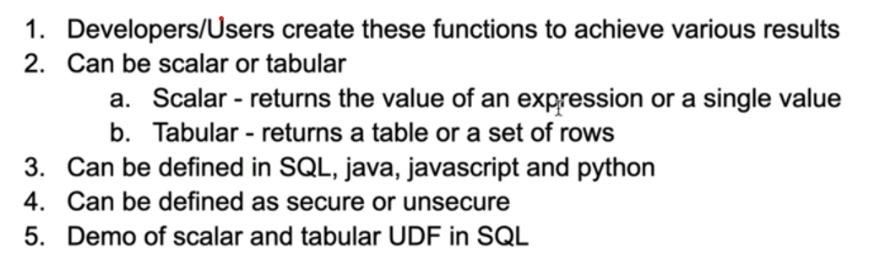

Let’s try to see this in practical
Let us create a scalar user defined function (explained everything in the image)
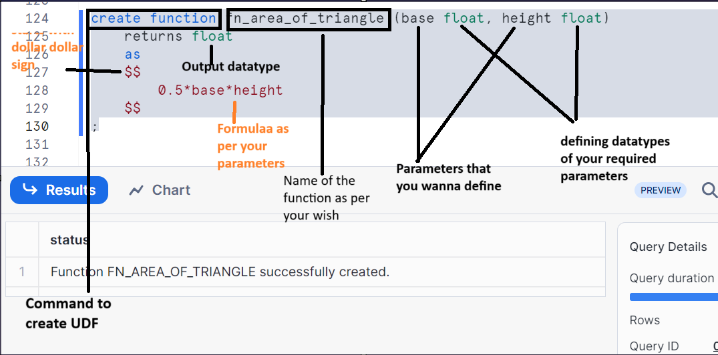

Calling your UDF by giving input parameters as defined
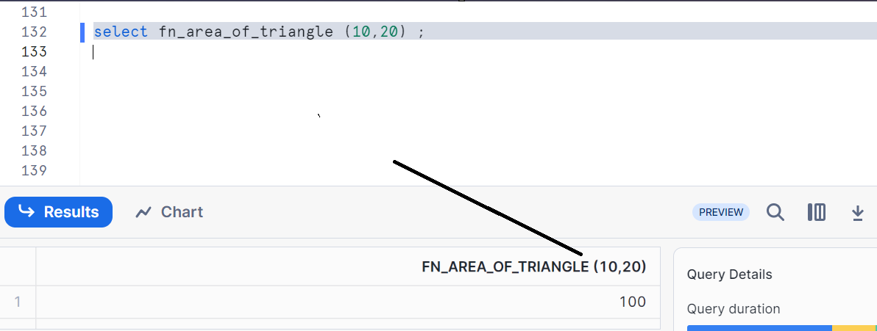

Now, let’s create tabular user defined function
Create any table
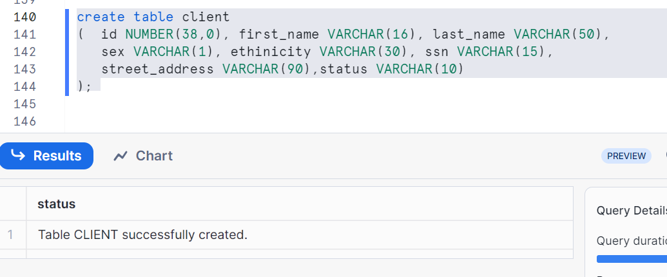
Inserting 5 rows
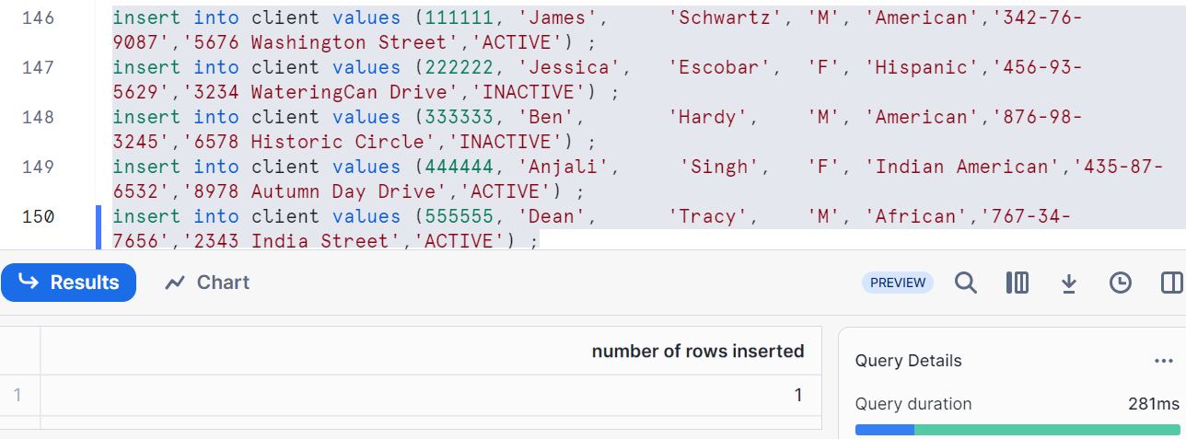
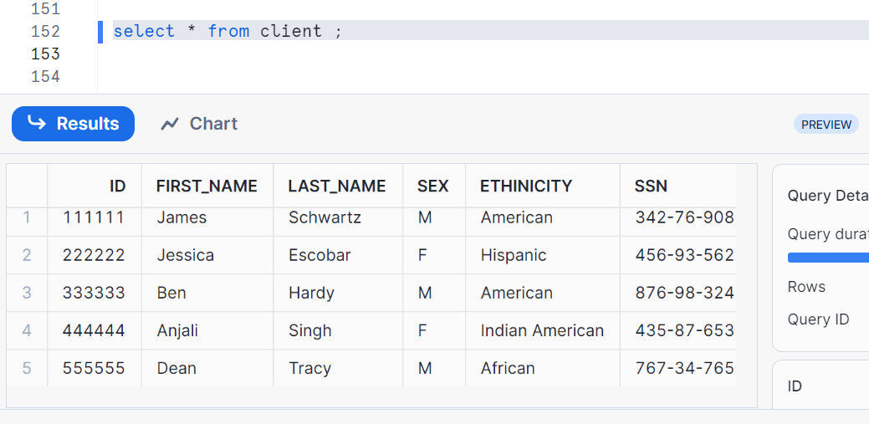
Now, let’s create a UDF
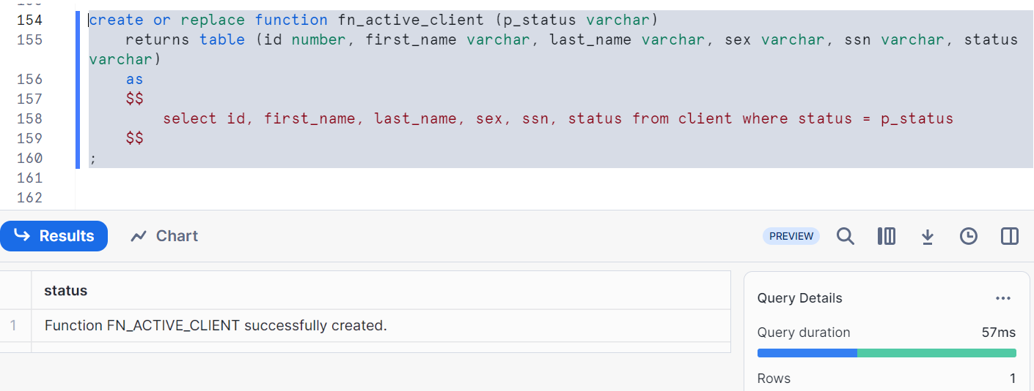
If you observe carefully, the function parameter is p_status.
Returns table – indicates that we want to return table containing the required columns that we want as mentioned
Inside $$, we have to give same columns as mentioned in returns table and while giving conditions, use parameters (we chosen p_status)
Here we had chosen only one parameter but you can use as many you want
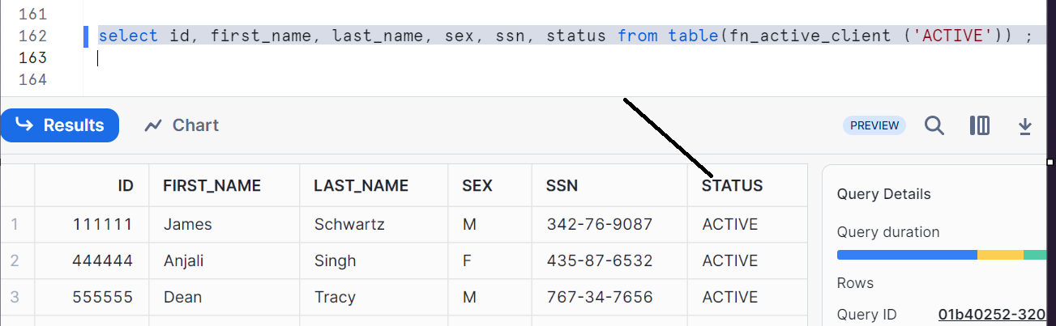
Hence we had given p_status as ‘ACTIVE’ while calling so that as per the condition in where clause (status = p_status), it takes ACTIVE and hence we got all the results related to status as ACTIVE

Stored procedures
Stored procedures allows you to write procedural code to execute the sql or operations in DB.
Stored procedures are called as independent statements and returning a value is optional

Let’s see in practical

Let’s create a staging table with name client_stg and insert values as shown below
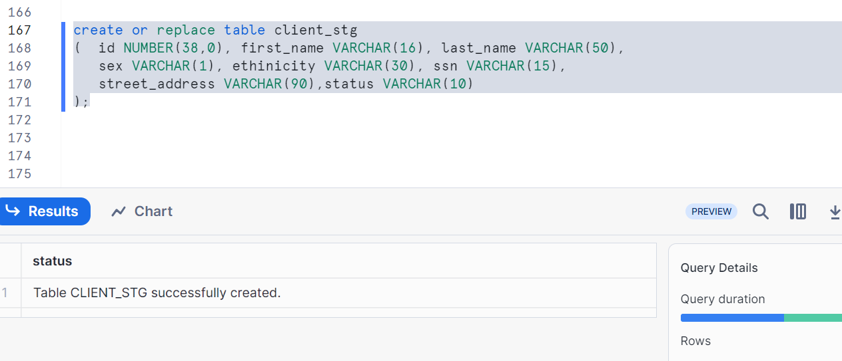

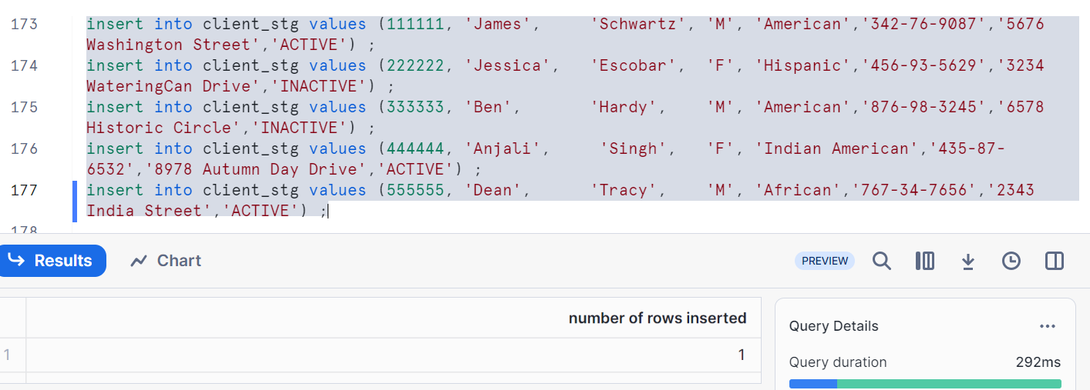
Let’s create a target table with name client_tgt as shown
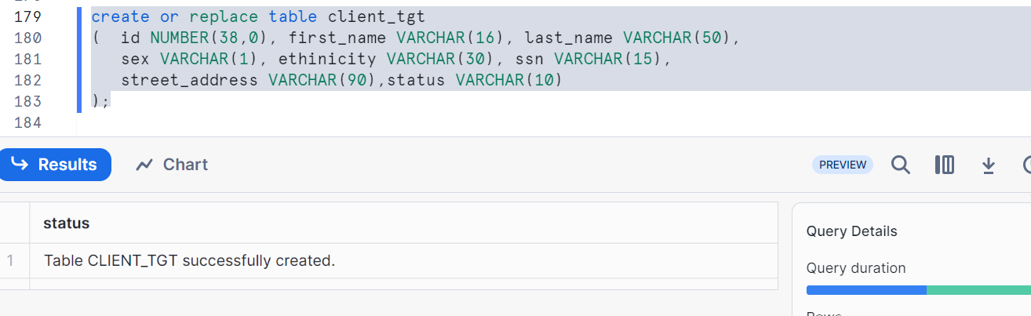
Now we have both table’s client_stg and client_tgt. So using stored procedures, we have to push the data from client_stg to client_tgt
Create a procedure as shown
Note: here our aim is to just push the data, Hence no parameters in procedure prc_load_client_tgt and use the syntax to push the data accordingly
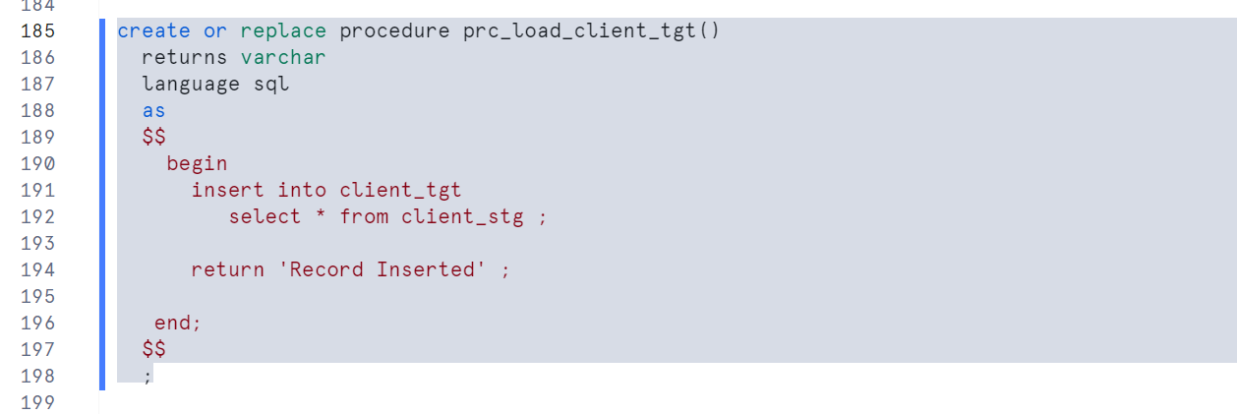

Testing
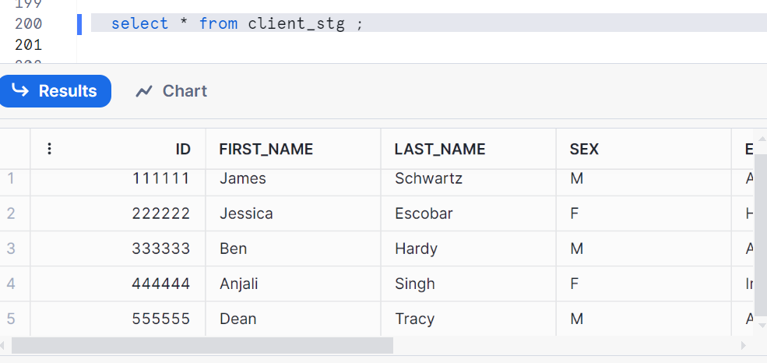
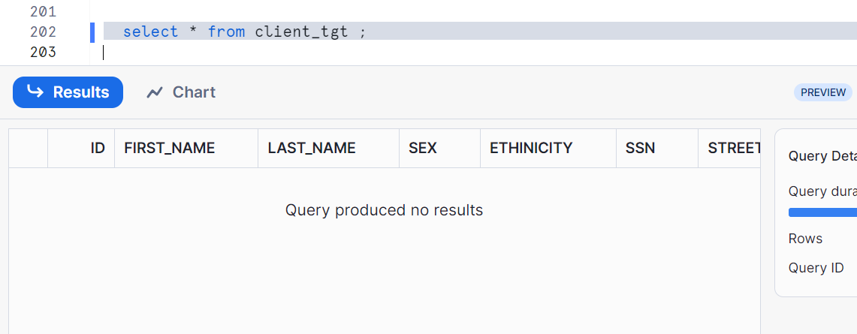
As there are no records in client_tgt. In order to get, we had to call the procedure function
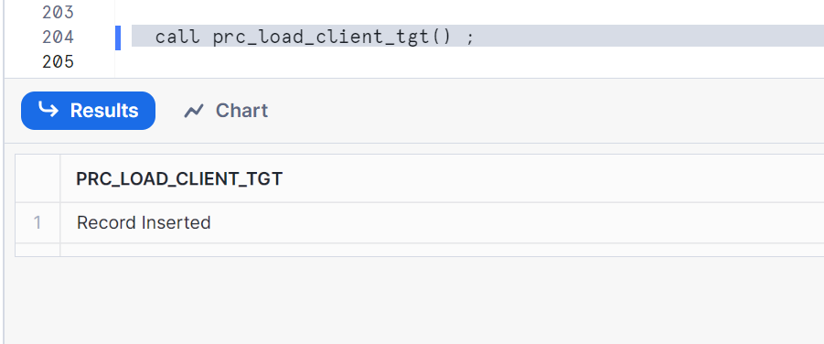
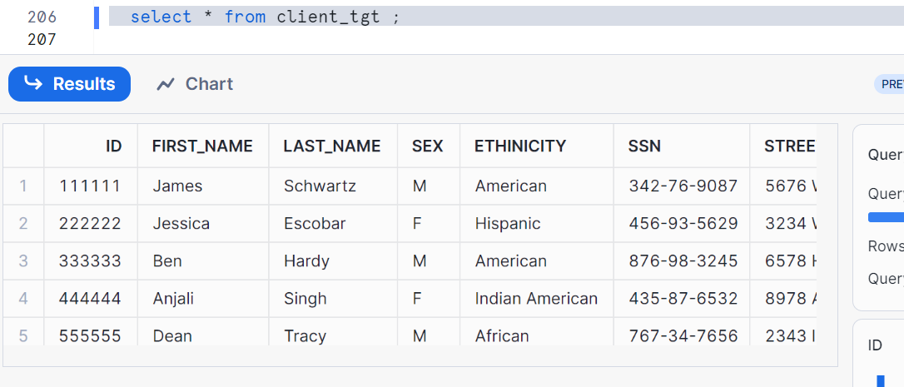
Yep, now we can see the data in client_tgt

Difference between UDF (user defined function) and SP (stored procedure)
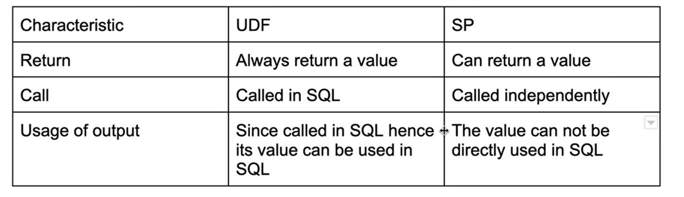

Secure UDF and stored procedures:
The main objective is to give access to users by denying some important info to users in the UDF’s or stored procedures
Let’s discuss step by step
- Create a role say developer role
- Create user say developer1
- Grant role developer_role to user developer_1
- Grant database and schema to developer_role
(Eg:
Grant all privileges on database training to developer_role;
Grant all privileges on schema demo to developer_role ;)
- Grant usage of function to developer_role
(Eg: grant usage on function fn_area_of_triangle (float, float) to developer_role ;
Grant usage on function fn_active_client (varchar) to developer_role ;)
Now login to developer1 and run as follows
You can see the details as shown and check as per the syntax
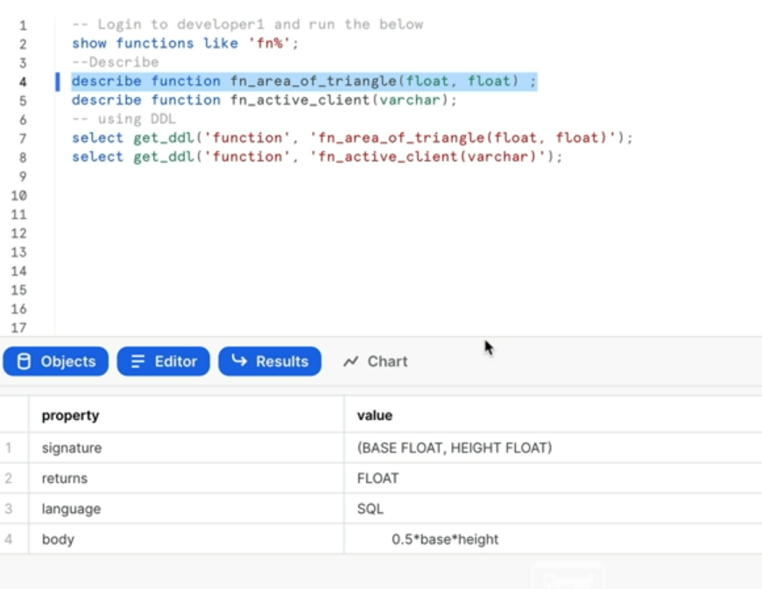
Entire information is shared to developer1 i.e. he got access
Now, you can make it Secure either while creating OR via ALTER post creation. Here is the syntax
Alter function if exists fn_active_client (varchar) set secure;
Alter function if exists fn_area_of_triangle (float, float) set secure;
Again go to developer1 account and check as follows
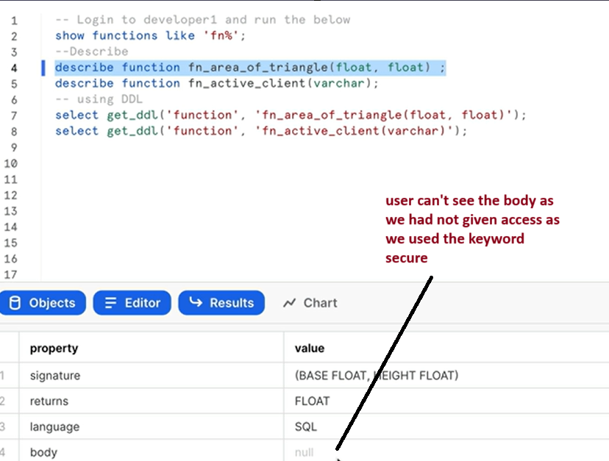
Similarly for stored procedures, do the same but one change is while creating SP, use a keyword secure while creating a procedure
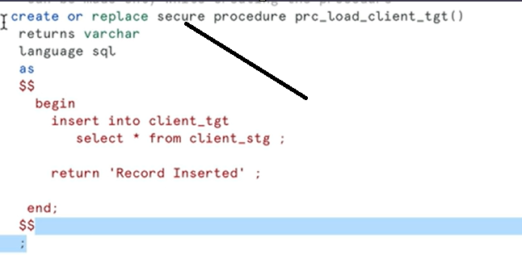
And give all the access to developer1 as we followed for UDF, now login to developer1
And check as follows
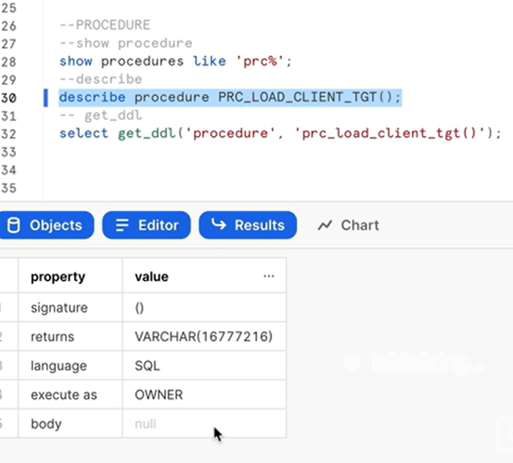
Note: get_ddl doesn’t work in case of Secured procedures

Thanks

